**Phần 1: SCCP**

Add IP cho router

int e0/0

ip add 192.168.17.200 255.255.255.0

Cấu hình router

telephony-service

auto-reg-ephone

max-ephones 10

max-dn 10

ip source-address 192.168.17.200 port 2000

system message CTK45-MMT

max-conferences 8 gain -6

transfer-system full-consult

create cnf-files version-stamp

ephone-dn 1

number 1001

label 2113039

description 2113039

name 2113039

ephone-dn 2

number 1002

label 2113039_2

description 2113039_2

name 2113039_2

ephone 1

device-security-mode none

mac-address 0000.AAAA.1001

button 1:1

type cicp

codec g711ulaw

ephone 2

device-security-mode none

mac-address 0000.AAAA.1002

button 1:2

type cicp

codec g711ulaw

Thông báo kết nối của 2 ephone





Giao diện 2 ephone sau kết nối

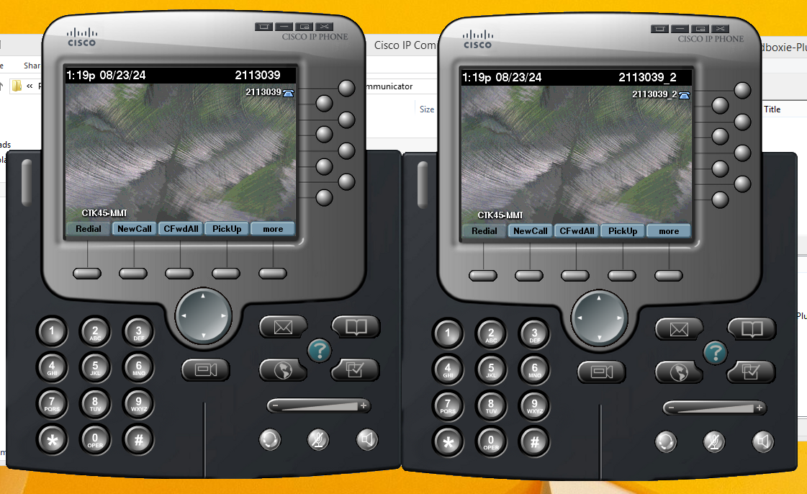

Ephone 1 gọi tới Ephone 2

2 Ephone đã gọi được cho nhau

**Phần 2: SIP protocol**

Add IP cho router

Int e0/0

Ip add 192.168.17.200 255.255.255.0

Cấu hình router

voice service voip

sip

registrar server

voice register global

mode cme

source-address 192.168.17.200 port 5060

max-dn 10

max-pool 10

authenticate register

authenticate realm all

create profile sync 0002254393144206

auto-register

voice register dn 1

number 2003

name 2113039

label 2113039

voice register dn 2

number 2004

name 2113039_2

label 2113039_2

voice register pool 1

id mac 0000.AAAA.2003

number 1 dn 1

username 2113039 password 2113039

codec g711ulaw

voice register pool 2

id mac 0000.AAAA.2004

number 1 dn 2

username 2113039_2 password 2113039_2

codec g711ulaw

Thông báo kết nối của 2 phone





2 phone đã kết nối

